Supports Broker
Training Registration & Online Training Instructions

- Go to www.myodp.org

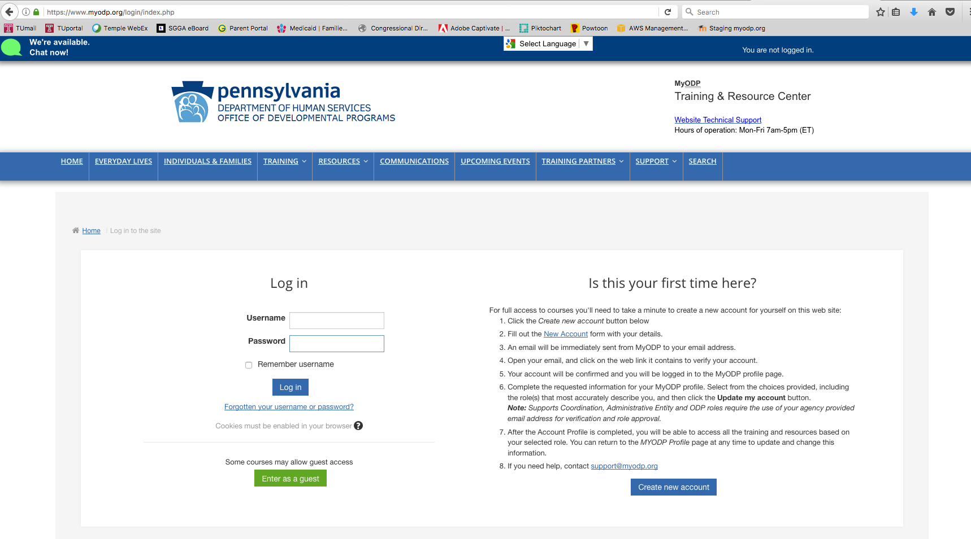
- Log-in or create an account by clicking log-in on the upper right corner of your screen. DO NOT ENTER AS A GUEST!
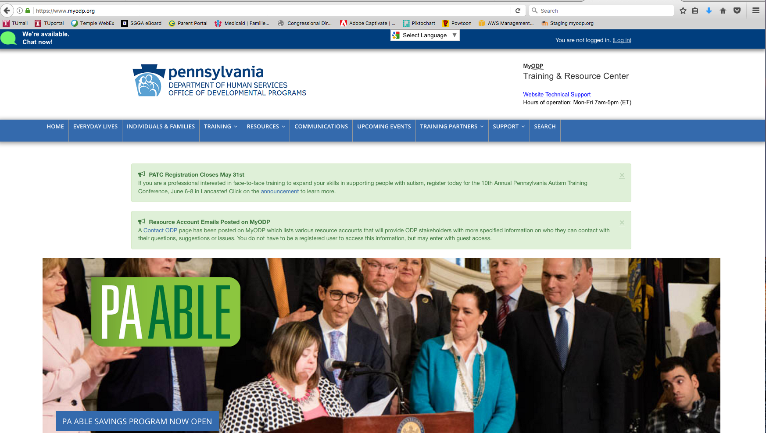
- After you create a log in, go to TRAINING > Intellectual Disability > Supports Brokers
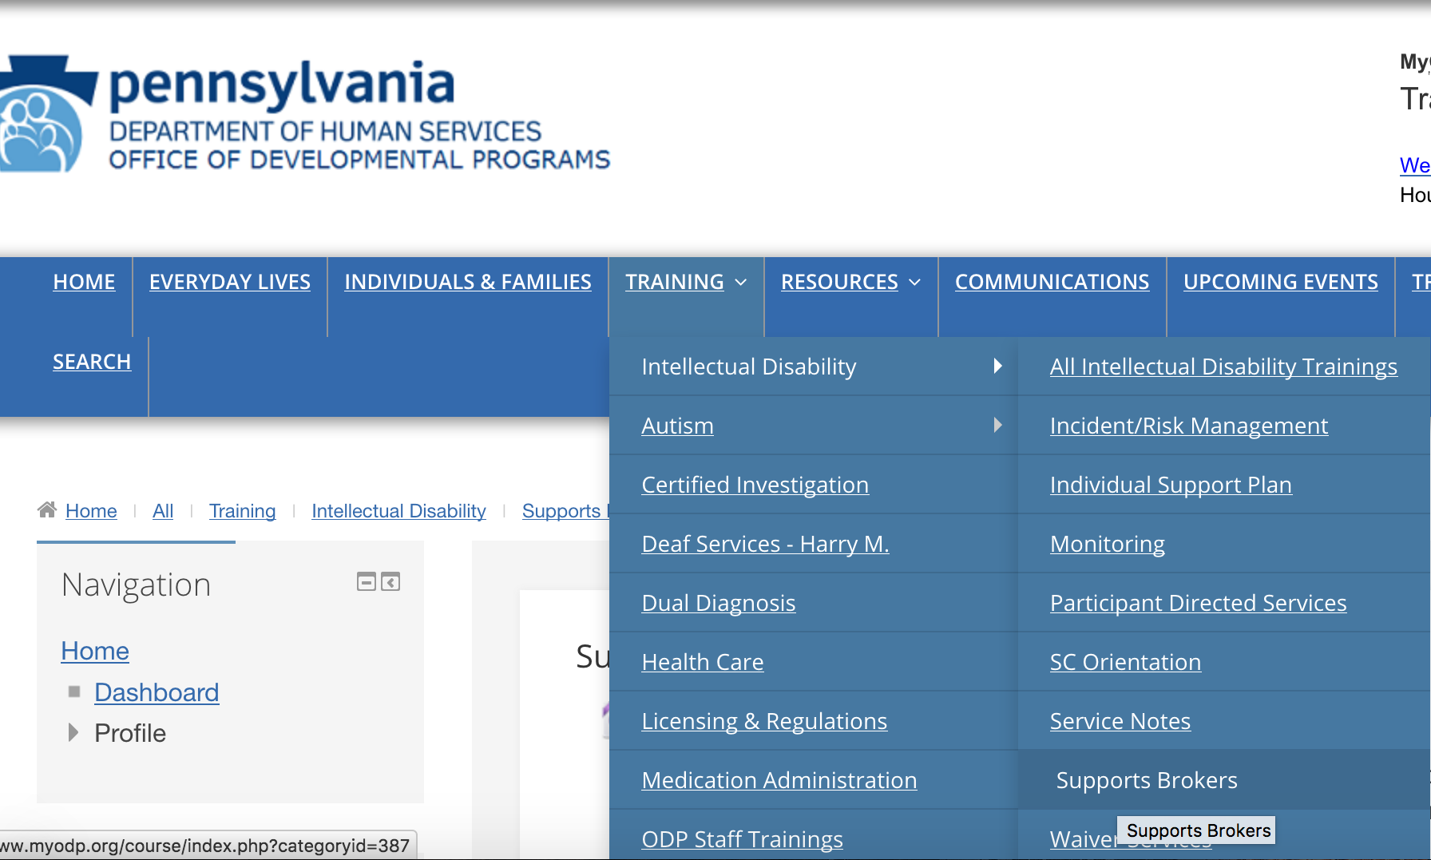

- Click “Supports Broker Online Training”

- REGISTER FOR CLASSROOM TRAINING --- At the top of the page, find the hyperlink to Register for the Classroom Training. Click this link and then “book” yourself in the Training

- BEGIN THE ONLINE PRE-REQUISITE TRAINING
Find “Supports Broker Dashboard” (see screenshot on next page)
  - Watch the “Introduction to Supports Broker Certification” video
  - Open the “Advanced Prep for Learners,” download and/or print materials that will be used in the online training. Each item is labeled accordingly
    - Review = Download and be prepared to review immediately
    - Print = Download and print, it is used in the online training
    - Future Review = It’s addressed in the training, you’ll want to review before becoming a broker

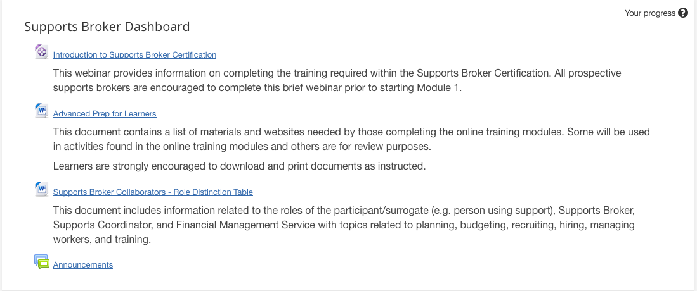

- Complete each training module by watching the video and completing the accompanying test.
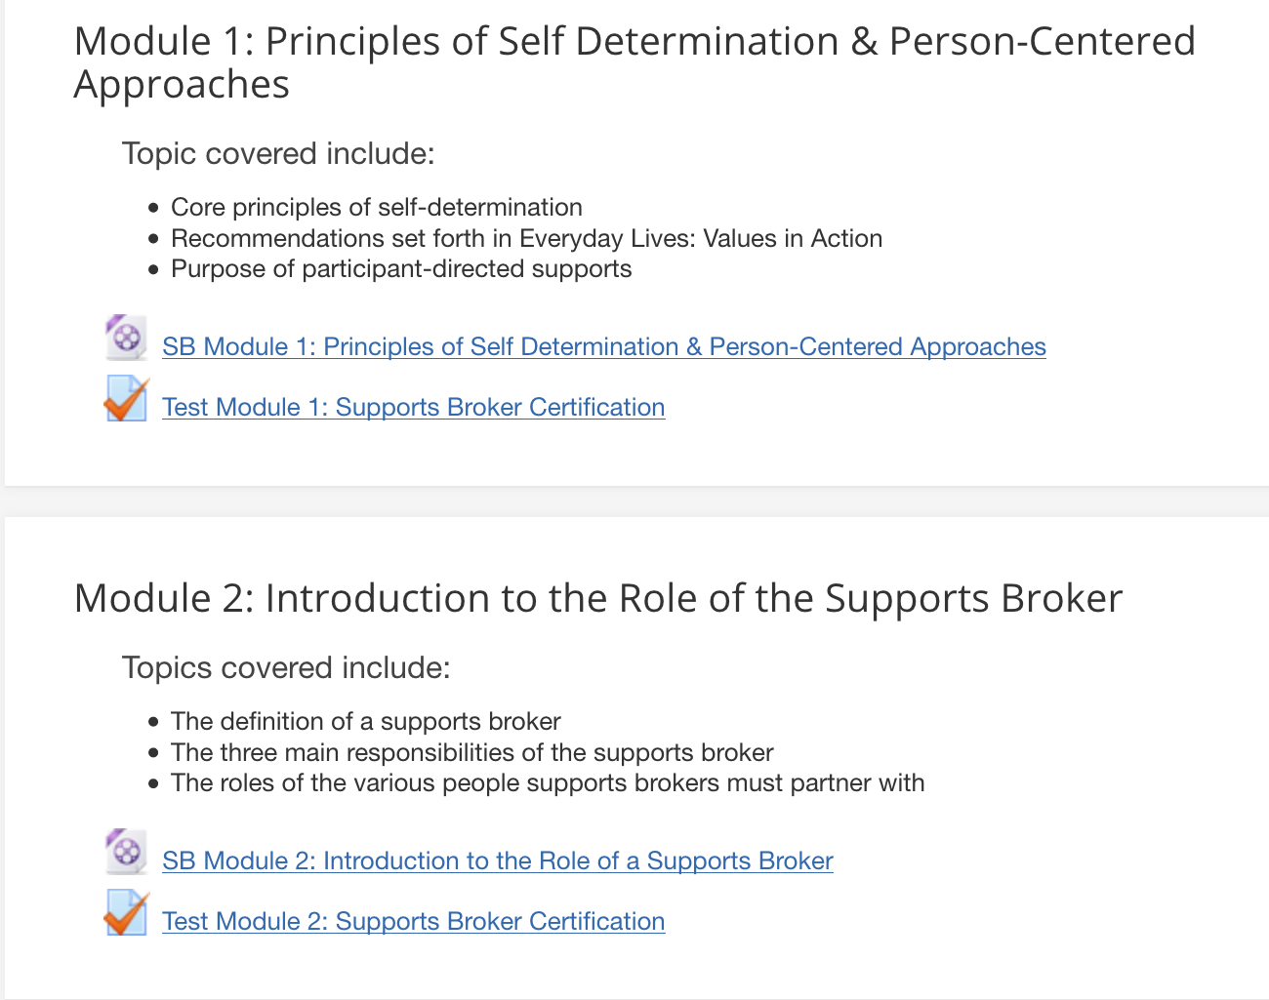

- Once you complete the test you click “Finish Attempt” at the bottom of the screen.

- On the next screen click “Submit all and finish”
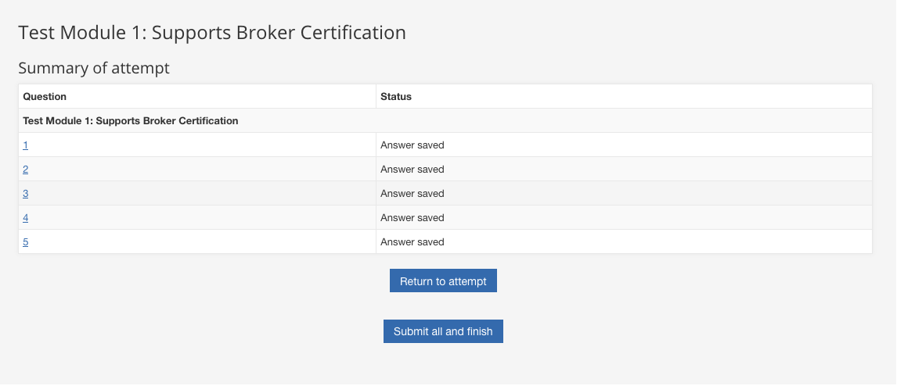
- You will be brought to a screen that gives your score. If you received a 100%, scroll down and click “Finish Review” in the lower right corner. This will register your successful completion.

- Once you’ve completed each module and successfully completed and reviewed each test you should see a checkmark to the right of the test.
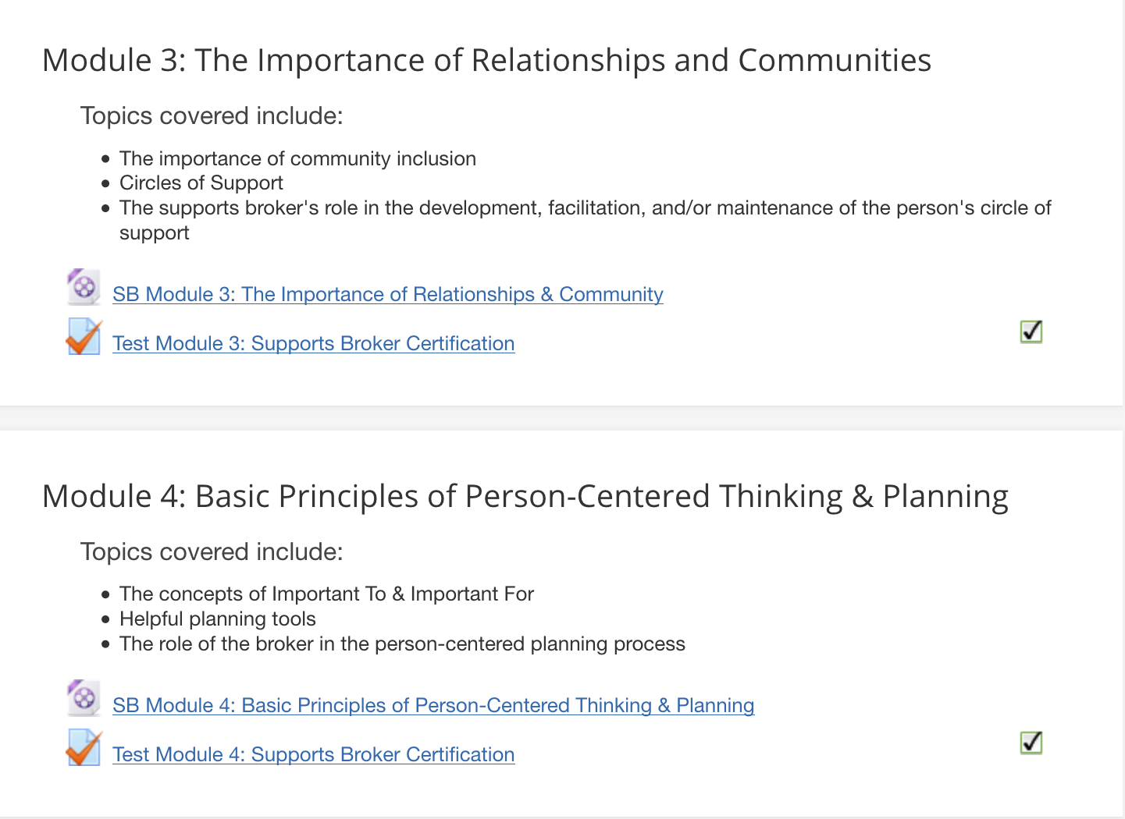

Trouble-shooting: If you do not see a checkmark, but did receive a 100%, please click the test hyperlink and review again making certain to click “Finish review.” This should display the checkmark.

- Once you’ve completed ALL 7 modules and received a 100% on all 7 tests you will be able to access the Certificate. Please save to your computer and email to dbeckett@temple.edu. You send it no later than a week before the classroom training.

