Emergency Preparedness Survey: Pennsylvanians with Disabilities and Access and Functional Needs

Institute on Disabilities, Temple University

*August, 2016*

Kevin Donley

Jamie Arasz Prioli

Amy Goldman

Sally Gould-Taylor

Table of Contents

Abstract 2

Introduction 3

Demographics 5

Emergency Knowledge and Planning 13

Discussion 20

Finding 1: Limited notification of needs to local authorities 20

Finding 2: Few people with emergency plans 21

Finding 3: Prevalence of difficulties with daily living activities 22

Implications for further study 24

References 26

Appendix A 28

# Abstract

The Institute on Disabilities (IOD) at Temple University, Pennsylvania’s University Center of Excellence in Developmental Disabilities, developed an online survey of emergency preparedness specifically designed for Pennsylvanians who have disabilities and other access and functional needs in order to inform emergency planning in the Commonwealth. The survey, funded by the PA Department of Health, was distributed through various electronic networks and was open for the month of March, 2016. Nearly 400 people responded to the survey, of whom approximately one-fourth indicated that they were a person with a disability or other access and functional needs, while the remaining respondents indicated they were support personnel, family members, or advocates for people with disabilities or access and functional needs. Demographic questions asked about the nature of respondents’ access and functional needs, living arrangements, and types of assistive technology used. Focused questions asked respondents about their knowledge of emergency terminology and levels of personal preparedness based on components of best practices in emergency planning (American National Red Cross, 2016). Key findings were that the majority of respondents had not informed local authorities of their disability or access and functional needs, nor did the majority of respondents have a specific emergency plan in place, and finally, that many respondents indicated needing assistance with activities of daily living (e.g., personal care, meal preparation, medication administration). Recommendations include emergency shelter staff training, strategies to promote personal preparedness, as well as inclusive emergency planning for the whole community.

# Introduction

While the term access and functional needs (AFN) applies to people with physical, sensory, mental health, cognitive, and/or intellectual and developmental disabilities (ID/D) that affect their ability to function without assistance, it also is used to describe people with temporary conditions, such as women in late stages of pregnancy, individuals with injuries, people needing bariatric equipment, or people who are non-English speakers (Office of the Assistant Secretary for Preparedness and Response [ASPR], 2016). As part of its work for the Pennsylvania Department of Health (DOH), the Institute on Disabilities (IOD) at Temple University conducted a survey in March, 2016 to inform emergency planners and related personnel of the unique needs of individuals who have access and functional needs, especially those with disabilities. This report was supported by Cooperative Agreement Number 5 NU90TP000545-05-00, funded by the Centers for Disease Control and Prevention and/or Department of Health and Human Services Assistant Secretary for Preparedness and Response. Its contents are solely the responsibility of the authors and do not necessarily represent the official views of the Centers for Disease Control and Prevention or the Department of Health and Human Services.

A total of 399 individuals responded to the survey, which was electronically disseminated to various disability-related listservs and databases by the IOD. Of the 399 respondents, 94 identified as a person with a disability; 126 respondents identified as a family member or caregiver answering on behalf of a person with a disability; 113 people identified as a support person or advocate answering on behalf of a person with a disability; and 66 individuals selected the “other” response choice. Of the respondents who selected “other,” 55 indicated an affiliation with a professional organization or service provider, including 13 who were affiliated with education, e.g., special education teacher or administrator. Figure 1 depicts the distribution of respondents as percentages.

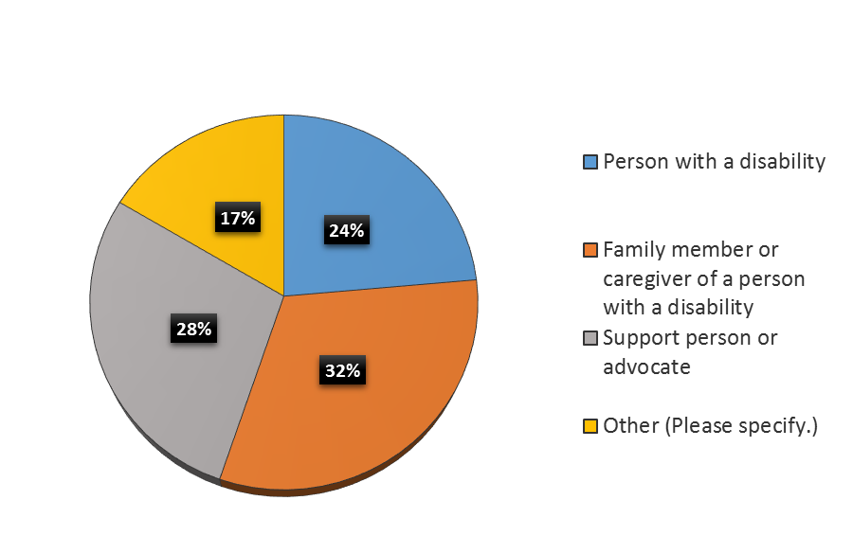

Figure 1. Distribution of Respondents' Identification

In order to simplify the comparative analyses, respondents who selected either “family member or caregiver of a person with a disability”, “support person or advocate”, or “other” were combined into a single group of 305 respondents. Although over 300 respondents identified themselves as advocates, caregivers, or “others,” nearly half of them did not complete any of the remaining survey items. Results should be interpreted cautiously in light of this sampling bias. All subsequent narrative and graphical analyses distinguished people with disabilities (PWD) from the advocates/caregivers/other (ACO) category. The electronic survey was divided into three sections: Demographics, Emergency Knowledge, and Emergency Plan. The Demographics section was composed of nine items; the Emergency Knowledge section was composed of seven items; and the Emergency Plan section was composed of two items. If respondents indicated that they or the person they were answering for did *not* have an emergency plan, they were routed to the “Thank You” page at the end of the survey. Respondents were also routed to the “Thank You” page if they indicated they were not a PA resident. Response rates across survey sections and items varied between respondent groups because there were no questions that required an answer.

# Demographics

The first item in the demographics section of the survey asked respondents whether they (or the person on whose behalf they were answering) identified as a person with a disability on the 2010 US Census. The survey included this item in order to understand respondents’ rate of disability identification to a source of information commonly used by emergency planners. Figures 2 and 3 show the percentages of people with disabilities (PWDs) and advocates/caregivers/others (ACOs) who indicated either “yes”, “no”, or “I don’t remember.”

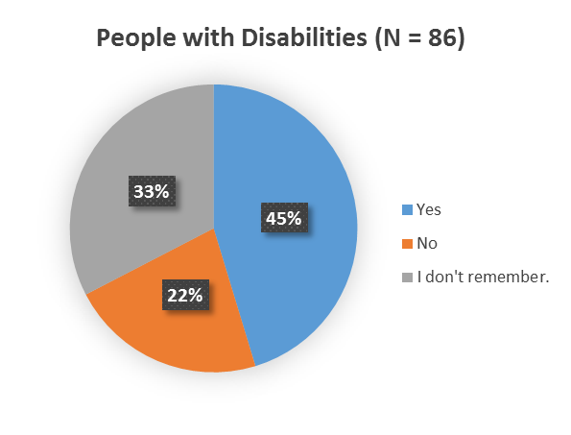

Figure 2. Disability Identification on 2010 US Census for PWDs

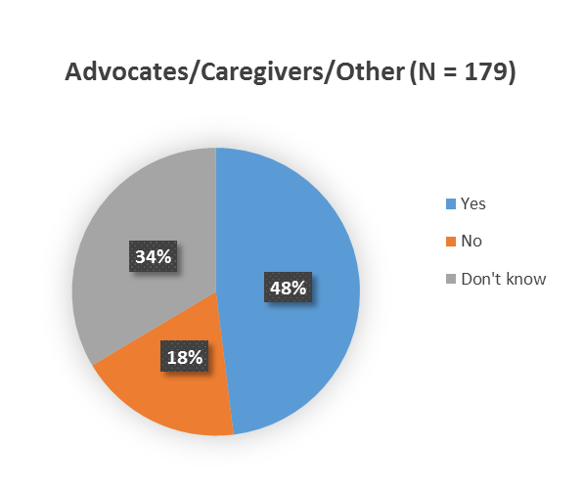

Figure 3. Disability Identification on 2010 US Census for ACOs

Respondents were asked to indicate which county they, or the person on whose behalf they were answering resided. Thirty-one percent of PA counties were represented by respondents who identified as a PWDs, and 49% of PA counties were represented for respondents who identified as ACOs. Counties were categorized as urban if the population density was greater than or equal to 284 persons per square mile, or rural if the population density was below 284 persons per square mile (Center for Rural Pennsylvania, 2014). The vast majority of respondents who identified as a PWD or as an ACO came from urban counties (88% and 84% respectively). Figures 4 and 5 graphically display the distribution of respondents across counties in Pennsylvania for respondents who identified as PWDs and ACOs. For a more detailed description of respondents by counties, see the tables in Appendix A. While there was statewide representation among survey respondents, it is not surprising to note that the majority of respondents were from Pennsylvania’s population centers. A similar survey targeting rural Pennsylvanians may or may not yield different results, and an effort to glean information regarding emergency knowledge and planning for people with disabilities or other access and functional needs specifically living in rural areas may need to be undertaken.

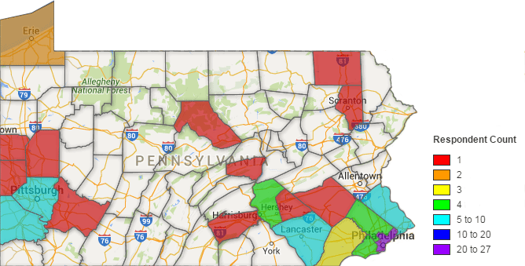

Figure 4. PWD Respondents by County

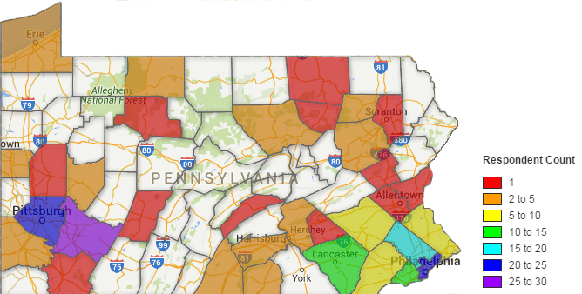

Figure 5. ACO Respondents by County

Based on the definition of access and functional needs provided by the Office of Assistant Secretary for Preparedness and Response, U.S. Department of Health and Human Services (ASPR, 2016), respondents were asked to indicate whether they, or the person they were answering on behalf of had any of the following disabilities or access and functional needs: visual impairment, hearing impairment, difficulty walking, difficulty manipulating objects, difficulty speaking or reading English, special dietary needs, chronic medical conditions, temporary conditions, and difficulty understanding or remembering. Percentages of respondents who indicated they or the person for whom they were answering had any of the aforementioned disabilities or other access and functional needs are shown in Figure 6. The majority of respondents who selected “other” indicated that they or the person for whom they were answering either had a specific psychological disorder as per the Diagnostic and Statistical Manual of Mental Disorders, Fifth Edition (DSM-V) (American Psychiatric Association, 2013), e.g., obsessive compulsive disorder, autism, or intellectual disability; or a specific musculo-skeletal or neurological disorder, e.g., cerebral palsy, muscular dystrophy, or spinal cord injury. It is interesting to note the difference between PWD and ACO respondents’ answers to response choices concerned with communicative difficulties, i.e., difficulty speaking or reading English and difficulty understanding or remembering. One reason for this finding may be that people with access and functional needs related to communication are less aware of their difficulties. In other words, people with access and functional needs may not know what they are not understanding unless it is brought to their attention. This finding may indicate a potential additional training need for emergency shelter personnel and first responders.

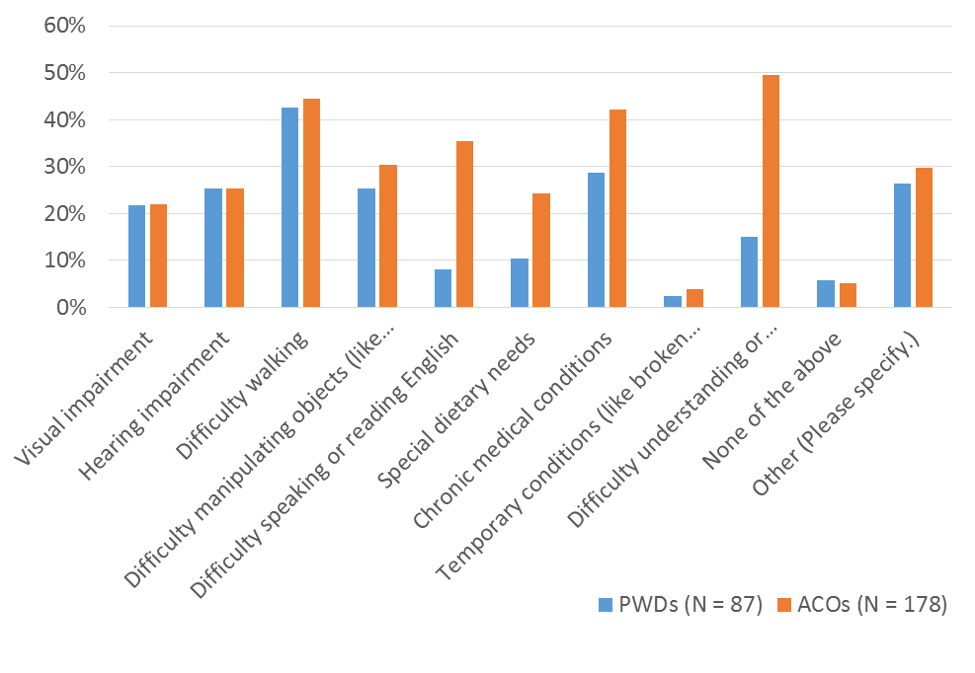

Figure 6. Distribution of Respondents' Difficulty across Types of Activities

Tables 1 and 2 show responses for people with disabilities (PWDs) and those who identified as advocates, caregivers, or other (ACOs) regarding the type of housing in which they or the person they were answering for resides. The majority of both PWD and ACO respondents reported living in a one-family house detached from any other houses.

Table 1. Distribution of Residential Living Status for PWDs

| **Type of Housing** | **Respondent Percentage** | **Respondent Count** |
| --- | --- | --- |
| A one-family house detached from any other house | 44% | 38 |
| A one-family house attached to one or more houses | 23% | 20 |
| A building with two apartments | 2% | 2 |
| A building with three or four apartments | 2% | 2 |
| A building with five to nine apartments | 6% | 5 |
| A building with 10 or more apartments | 14% | 12 |
| A multiple family house detached from any other house | 2% | 2 |
| A multiple family house attached to one or more houses | 1% | 1 |
| Supported living or group home | 3% | 3 |
| Mobile home | 1% | 1 |
| Other (Please specify.) | 1% | 1 |

Table 2. Distribution of Residential Living Status for ACOs

| **Type of Housing** | **Respondent Percentage** | **Respondent Count** |
| --- | --- | --- |
| A one-family house detached from any other house | 50% | 89 |
| A one-family house attached to one or more houses | 11% | 20 |
| A building with two apartments | 2% | 4 |
| A building with three or four apartments | 1% | 2 |
| A building with five to nine apartments | 3% | 6 |
| A building with 10 or more apartments | 4% | 7 |
| A multiple family house detached from any other house | 1% | 2 |
| A multiple family house attached to one or more houses | 2% | 4 |
| Supported living or group home | 16% | 28 |
| Mobile home | 2% | 3 |
| Other (Please specify.) | 7% | 13 |

In order to better understand where people with disabilities or other access and functional needs spent their time the next question on the survey asked respondents to indicate which floor of their residence, or the residence of the person for whom they were responding primarily spent their waking and sleeping hours. The results are displayed in Figure 7. The majority of PWDs and ACOs reported that they or the person for whom they were answering spent most of their waking hours on the first floor of their residence while more PWDs reported sleeping on the first floor of their residence than the second, third, fourth, or higher levels of their residence.

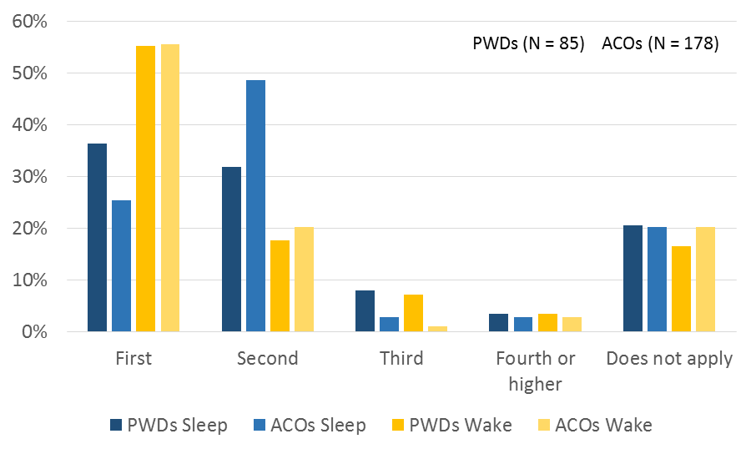

Figure 7. Time Spent During Sleeping and Waking Hours by Floor of Residence

Figures 8 and 9 display the distribution of PWD and ACO respondents’ answer to the question, “With whom do you or the person for whom you are answering live?” Both PWD and ACO respondents primarily reported that they or the person for whom they were answering lived with family members or friends.

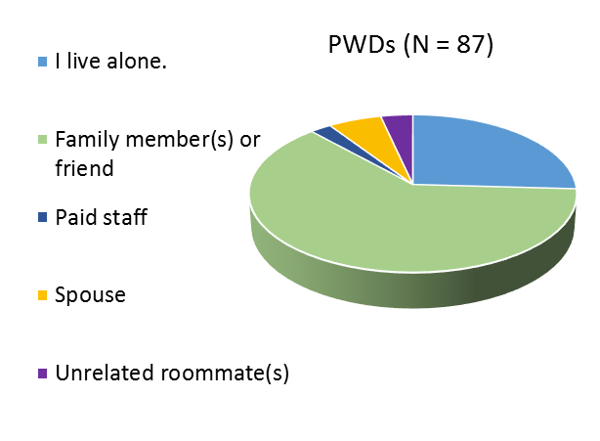

Figure 8. Living Arrangements for PWDs

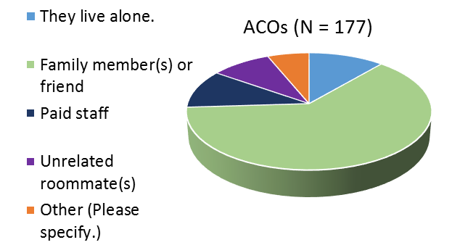

Figure 9. Living Arrangements for ACOs

Responses to the questions about residential living status (type of dwelling and living arrangement) and location of time spent during waking and sleeping hours highlight the variability among people with disabilities and their families, and dispel any misconception emergency managers might have that people with disabilities or other access and functional needs reside in supported living, group homes, or other congregate settings.

Finally, the demographic portion of the survey asked respondents to indicate those activities with which they or the person for whom they were answering usually required help and to indicate assistive technology devices and durable medical equipment they or the person for whom they were answering used. Figure 10 displays the number of respondents who indicated needing help with various activities, and Table 3 shows percentages of respondents’ answers regarding various types of assistive technology and durable medical equipment used.

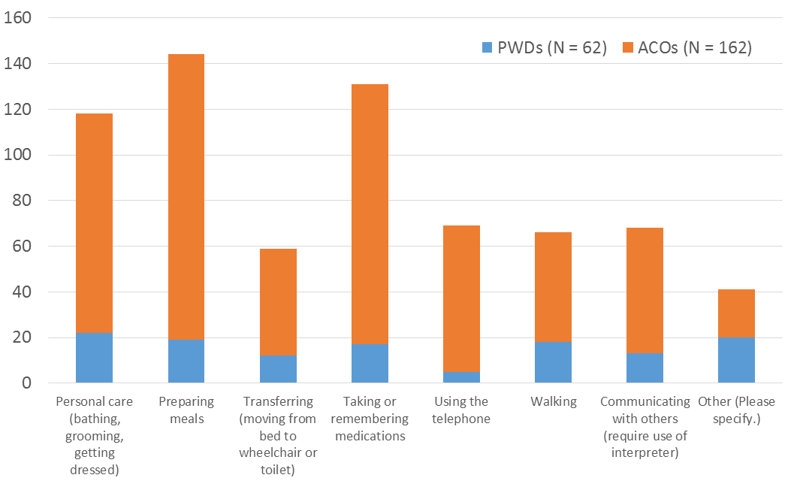

Figure 10. Distribution of Respondents Needing Help with Daily Activities

Of the PWD respondents who indicated “other” for the question asking about help with daily activities, four wrote in “none” or “NA;” seven said they needed help understanding speech or some other form of assistance with communication, e.g., captioning; four said they needed help with household chores; and three said they needed help with motor tasks. Of the ACO respondents who selected “other” for this question, four wrote in some form of communication issue, e.g., “does not speak;” four wrote in some sort of transportation or mobility issue, e.g., “assistance with shopping and carrying items;” and four indicated needing help with daily living activities, e.g., housework and laundry.

Results from this question indicate that both PWD and ACO respondents expressed needing help with personal care, preparing meals, and taking/remembering medications more so than any other response choice. These activities can be subsumed under a larger category of daily living activities and should be taken into consideration for emergency shelter personnel who may need to be trained in providing specialized assistance with activities of daily living for people with access and functional needs, especially those with disabilities and difficulties with communication.

Table 3. Usage of Assistive Technology and Durable Medical Equipment

| **Type of Assistive Technology or Durable Medical Equipment** | **PWD (N = 85) Percentage** | **ACO (N = 172) Percentage** |
| --- | --- | --- |
| Ramp | 25% | 25% |
| Walker, cane, or crutches | 21% | 24% |
| Wheelchair or scooter | 37% | 31% |
| Gait belt, transfer board, or patient lift | 6% | 9% |
| Bedside commode, shower chair or handheld shower wand | 28% | 27% |
| Adapted utensils, plates, dishes, bendable straws or cups | 7% | 15% |
| Reacher | 22% | 6% |
| Dressing tools (like a sock donner, button pull, dressing stick) | 9% | 5% |
| Captioned, amplified or large button telephone | 9% | 4% |
| Hearing aids | 17% | 19% |
| Video relay service | 14% | 3% |
| Vibrating or flash alert system | 18% | 5% |
| Magnifier | 13% | 4% |
| Eyeglasses | 47% | 44% |
| "High tech" communication device (iPad, tablet or other specialized speech generating device) | 17% | 19% |
| Picture or letter communication board | 1% | 12% |
| Non-skid activity material (Dycem or similar) | 5% | 9% |
| Handheld reminder or digital recorder | 8% | 2% |
| None | 14% | 19% |
| Other (Please specify) | 12% | 9% |

Response rates for the question about daily activities were 66% and 53% for PWDs and ACOs respectively, while response rates for the question asking about assistive supports were 90% and 56% respectively. The low response rate for PWDs on the question about needing assistance with daily activities was surprising given that nearly all other survey items reached a response rate of approximately 90% or more. One of the reasons for this may have been the lack of a “none” response choice. PWD respondents who selected “other” (12%) wrote in responses that could generally be categorized as one of the various assistive device choices presented.

Results from the question asking about assistive supports showed that many nearly half of respondents required the use of eyeglasses, and one-fifth used hearing aids, and around one-third of respondents used a wheelchair or scooter. While it is not possible to provide personal aides, these findings support recommendations made in planning guides regarding provisions for specific assistive technology and durable medical equipment (IOD, in press).

# Emergency Knowledge and Planning

The survey asked a series of questions designed to gauge respondents’ knowledge of terminology commonly used in referencing emergencies and their knowledge of what to do in the event of emergency or disaster. The first item of this section asked respondents whether they or the person for whom they were answering understood what the terms, “shelter in place,” “evacuate,” “lockdown,” “emergency,” and “disaster” meant. These terms were chosen because of their high frequency of use in public information instructions via TV, radio, and social media announcements in the event of emergency or disaster. Results are displayed in Figure 11.

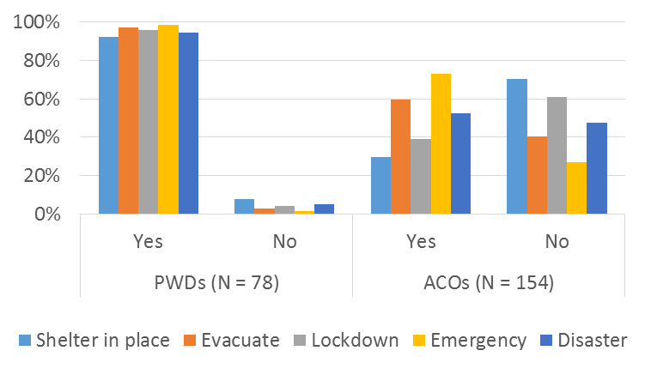

Figure 11. Respondents’ Knowledge of Emergency-related Terms

The most apparent finding from this item is the discrepancy between how PWD and ACO respondents reported their understanding of emergency-related terms; mainly, that PWDs by and large reported knowing what all of the terms meant, whereas many of the ACOs responding on behalf of a person with disabilities reported variability in whether the person for whom they were answering knew what the terms meant. This finding may not be surprising when considering the likelihood that the person on whose behalf ACOs were responding may have had more significant needs than PWDs who responded on their own behalf. Another explanation for these results may be that PWD respondents were less likely to report not knowing what the terms meant because of a tendency to respond in a socially-desirable way, acquiescing to what others in their lives would want them to say. Recommendations for clarifying respondents’ understanding of emergency-related terms are presented in the “Implications for further study” section at the end of this report.

The next two questions on the survey asked respondents 1) whether they or the person on whose behalf they were responding knew what they would do in an emergency if they had to quickly leave from places where they and their family spend time (e.g., work place, school, shopping center), and 2) whether they or the person for whom they were answering knew where to goif they had to leave home/school/a workplace in an emergency. Percentages of respondents knowing where to go or what to do are displayed in Figure 12.

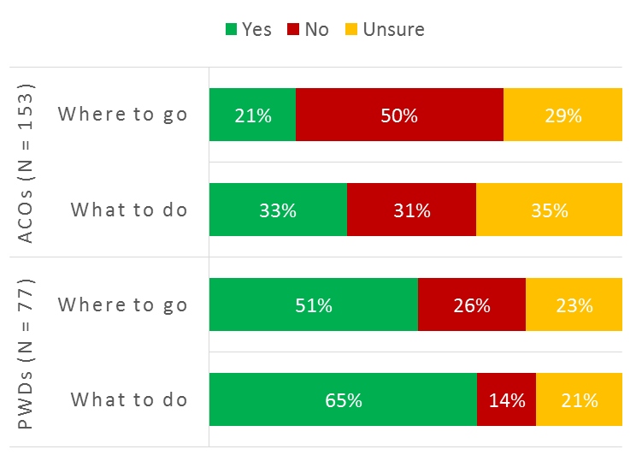

Figure 12. Respondents’ Knowledge of What to do and Where to go in an Emergency Situation

The survey asked respondents whether they or the person for whom they were answering knew *how* they would leave an emergency or disaster area. The responses for this item are displayed in Figure 13. The majority of ACO respondents (54%) indicated that the person for whom they were answering would not know how to leave an emergency or disaster area, which indicates more support is needed to both educate and assist people with significant needs about appropriate emergency or disaster situation protocols and procedures.

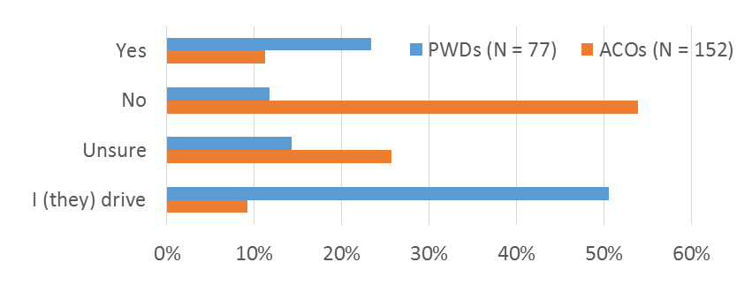

Figure 13. Respondents’ Knowledge of How to Leave an Emergency or Disaster Area

The next item on the survey asked respondents if they or the person for whom they were answering had contacted their local fire/police department or power company to let them know they have special needs that might impact their ability to shelter safely in place, or to evacuate. Results are displayed in Figure 14. Significantly, the majority of both categories of respondents indicated that they had not contacted their local authorities to alert them of their special needs.

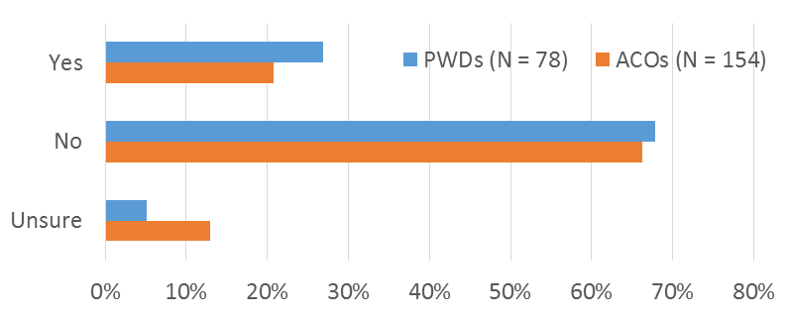

Figure 14. Respondents who have Contacted Local Fire/Police Departments or Power Company

Figure 15 displays responses to the survey item asking respondents to select how they received information about emergencies or disasters in their area from the following list of choices: television, social media (like Facebook, Twitter, and others), telephone, video relay, radio, internet, neighbor or friend, look outside, police or other first responders, or unsure. One-third of ACO respondents utilized the “other” response choice. Inspection of written responses revealed that 45 out of 51 (88%) “other” responses indicated that the person for whom the ACO was responding would receive information from staff, caregivers, or family members. As per these findings, given the importance of social media and the Internet as a means for individuals to receive information about emergency or disaster situations, emergency planners should continually monitor trends, utilization, and accessibility of these platforms and applications.

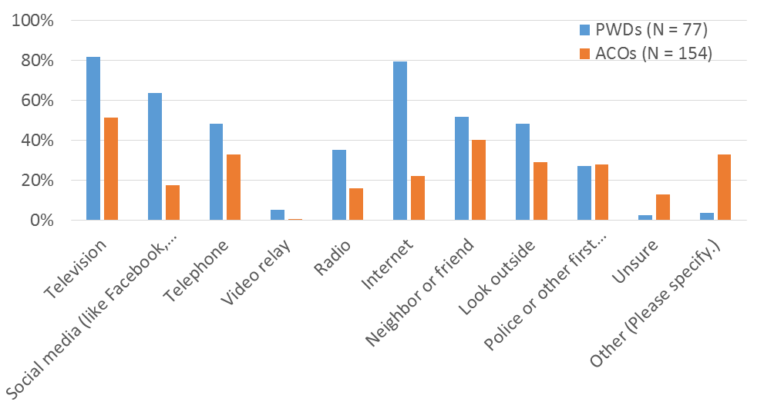

Figure 15. Channels of Emergency-related Information

The survey asked respondents whether they or the person for whom they were answering had an emergency plan. The majority of respondents, both PWDs and ACOs, indicated that they or the person for whom they were answering did *not* have an emergency plan. Figure 16 displays responses for this question.

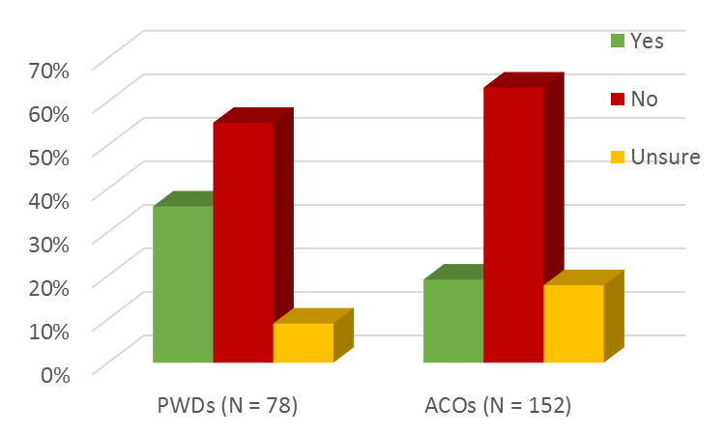

Figure 16. Emergency Plan across Respondents

Only twenty-eight PWD respondents and 29 ACO respondents indicated having a personal emergency plan, while seven PWD and 27 ACO respondents indicated they were unsure whether they or the person they were answering for had an emergency plan. Additional survey items regarding personal emergency plans were directed to these respondents.

The first question related to personal emergency plans asked respondents to indicate the components included in their plan. Response choices were consistent with the Federal Emergency Management Agency’s (FEMA) outline for emergency plan considerations (FEMA, 2016) and included, “what to do if you lose power for two or more hours,” “what to do if you lose heating or air conditioning for two or more hours,” “ways to quickly get out of your home,” “an out-of-town contact(s),” “a supply kit that has enough food, water, and other supplies to last for at least three days on your own,” “a portable bag that contains the gear and supplies you would need if told to quickly leave your home,” “a card describing any difficulties with communication,” “a medical information card,” “none of the above,” and “other.” The percentages of respondents’ answers are displayed in Table 4 below.

Table 4. Components of Respondents’ Personal Emergency Plan

| **Emergency Plan Components** | **PWD (N = 35) Percentage** | **ACO (N = 56) Percentage** |
| --- | --- | --- |
| What to do if you lose power for two or more hours | 79% | 60% |
| What to do if you lose heating or air conditioning for two or more hours | 63% | 55% |
| Ways to quickly get out of your home | 73% | 80% |
| An out-of-town contact(s) | 52% | 28% |
| A supply kit that has enough food, water, and other supplies to last for at least three days on your own | 52% | 35% |
| A portable bag that contains the gear and supplies you would need if told to quickly leave your home | 48% | 20% |
| A card describing any difficulties with communication | 6% | 13% |
| A medical information card | 42% | 58% |
| None of the above | 9% | 0% |
| Other (Please specify) | 12% | 0% |

The last question on the survey asked those respondents with emergency plans to indicate whether they or the person for whom they were answering had a medical information or communication card, and polled respondents on whether the medical information or communication card contained any of the following information: “contact information for family members, members of your support network, caregivers, work and school,” “out-of-town contact information,” “meeting locations,” “emergency service contact information (police and fire department phone numbers, shelter locations, etc.,” “medical providers,” “equipment you use,” “allergies and sensitivities,” “special medications and instructions,” “problems you have speaking, understanding, or remembering,” and “other.” Response choices were again based on FEMA’s guidelines for information to include on medical or communication cards specific to people with disabilities or other access and functional needs (FEMA, 2016). The distribution of various information contained on medical and communication cards across respondents who indicated having a medical information or communication card is displayed in Figure 17 (responses indicating lack of a medical information or communication card were removed from analyses). Written responses in the “other” category for both PWD and ACO respondents could generally be classified into one of the response choices.

Results from questions about personal emergency plans and information on medical or communication cards highlight the low number of respondents who indicated that they or the person for whom they were answering had (or were unsure if they had) a personal emergency plan (45% of PWD respondents and 37% of ACO respondents). Additionally, of this subset of respondents only 48% of PWDs (N = 17) and 50% of ACOs (N =28) indicated that their personal emergency plan contained a medical information or communication card. The initial sample size at the beginning of the survey totaled 399 respondents (94 PWD respondents and 305 ACO respondents), and in the end, only 18% of PWD and 10% of ACO respondents reported having a medical information or communication card as part of their personal emergency plan.

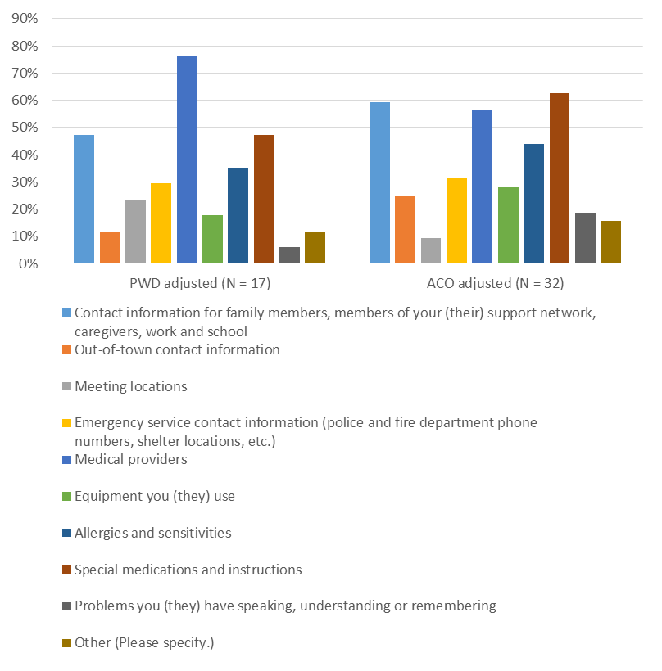

Figure 17. Information on Medical or Communication Cards across Respondents

## Discussion

In general, the broad definition of access and functional needs may have introduced some confusion for this sample of respondents as many of the individuals who participated in the survey wrote in psychological or mental health disorders on the item that asked about what types of difficulties they or the person for whom they were answering required help. A more standardized method of discussing the topic of access and functional needs as well as collecting and compiling this data may be helpful for future survey instruments. Nonetheless, several findings emerged and implications and recommendations for emergency preparedness and management personnel as well as for future study are discussed below.

### Finding 1: Limited notification of needs to local authorities

The vast majority of survey respondents, both people with disabilities (PWDs) and advocates/caregivers/others (ACOs), indicated that they or the person for whom they were answering had not contacted local fire/police departments or their local power company to let them know they have disabilities or other access and functional needs; thus, emergency management personnel are less likely to know who may require special consideration in emergency or disaster situations.

#### Recommendation

This finding should be addressed through targeted emergency preparedness campaigns that proactively encourage more people with disabilities or other access and functional needs and their caregivers, family members, friends and advocates to inform local authorities of their needs in event of emergency or disaster. However, any effort to establish or promote a registry must clarify that such an action does not imply any priority status (e.g. that their power would be restored first).

Cross-referencing disability status information collected through the US Census may help local authorities and utility service providers develop outreach campaigns that target people who need special consideration in emergency or disaster situations. US Census data should be used cautiously as nearly one fifth of survey respondents indicated that they or the person for whom they were answering did not claim disability status on the 2010 US Census. Multiple sources of data including the Behavioral Risk Factor Surveillance System (BRFSS) telephone survey database, the U.S. Department of Health and Human Services emPOWER interactive online map, and local registries should be utilized in conjunction with US Census data. Links to these resources can be found in the References section.

### Finding 2: Few people with emergency plans

Responses from the item asking respondents to indicate whether they or the person they were answering for had an emergency plan revealed that the majority of respondents said that they or the person they were answering for did not have a personal emergency plan. Additionally, many respondents who did report having a personal emergency plan did not include a medical information card, or a card describing any difficulties with communication as a component of their plan.

#### Recommendation

In line with recommendations from the National Council on Disabilities (NCD) (2014) report “Effective Communications for People with Disabilities: Before, During, and After Emergencies” emergency planners should include people with disabilities or other access and functional needs in developing and implementing public preparedness campaigns that address contingencies for specific emergencies or disasters. Best practices for what this public awareness campaign to promote personal preparedness specifically among people with disabilities and other access and functional needs should include preparing a personal emergency kit, making a plan, and staying informed. The U.S. Department of Homeland Security in consultation with AARP, the American Red Cross, and the National Organization on Disability worked with the FEMA Office of Disability Integration and Coordination to produce an informative brochure outlining these best practices and can be downloaded from the web (FEMA, 2015). In addition, the Institute on Disabilities at Temple University has created several resources focused on personal preparedness, including:

*My Emergency Readiness Plan- PA*: This document is an interactive form designed to help people with disabilities create personal plans to prepare themselves, their families and their supports for emergencies. Local emergency planners and service providers should make efforts to distribute this information to people with disabilities and other access and functional needs in their area, taking care to thoroughly explain and discuss details with their constituents (Institute on Disabilities [IOD], 2016).

*Emergency Communication 4 ALL Aids*:This document is a printable tool that features low tech communication icons commonly used by people with communication disabilities and by people who do not speak English during an emergency. Designed for people with disabilities as well as emergency shelter workers and first responders, these aids can be downloaded at no cost (IOD, 2016).

*Are You Ready? Emergency Preparedness for Individuals with Disabilities:* This archived webinar (recorded in 2014) presents strategies in preparing individuals who have a variety of needs (including access and functional) for disasters and emergencies (IOD, 2016).

*Encountering People with Disabilities in Emergency Situations:* This webinar (recorded in 2013) is designed for first responders and describes strategies on how to communicate with people with disabilities (IOD, 2016).

Emergency planning personnel are tasked with providing shelter and care for all individuals regardless of their specialized needs, and oftentimes conditions within shelters during emergency or disaster situations may be chaotic. The neurophysiological response to periods of heightened stress can impact thinking abilities associated with memory and communication in any individual with or without access or functional needs or disabilities (McEwen & Sapolsky, 1995). Therefore, emergency shelter personnel may find that individuals with access and functional needs, especially those with communicative difficulties and other disabilities, cannot articulate and express their thoughts and needs clearly, or remember pertinent information. Combined with the finding that many people with access and functional needs, especially those with disabilities may possess little to no information about their needs, it is vitally important that those working as responders be trained in assessing these needs and interacting effectively with this population (NCD, 2014).

### Finding 3: Prevalence of difficulties with daily living activities

When asked about what types of activities PWD and ACO respondents needed help with, many respondents indicated needing assistance with daily living activities and personal care, i.e., preparing meals, taking or remembering medications.

#### Recommendation

Training is necessary to ensure that emergency personnel and first responders are effectively assisting and communicating with people with disabilities and others with access and functional needs about their daily living activity and personal care needs. As noted by the Department of Justice (2014), “A critical and often overlooked component of ensuring success is comprehensive and ongoing staff training. Covered entities may have established good policies, but if front line staff are not aware of them or do not know how to implement them, problems can arise.”

By making efforts to coordinate and collaborate with subject matter experts and key stakeholders in emergency preparedness and disability studies, e.g., regional disability integration specialists from FEMA, statewide Centers for Independent Living (CILs), and University Centers for Excellence in Developmental Disabilities Education (UCEDDs), training for emergency professionals can be more effectively structured to best identify and ensure assistance with daily living and personal care activities for people with access and functional needs, especially those with disabilities. Creating a model template for training should include partnerships with PEMA, PA DOH, state ADA coordinators, the American Red Cross and other organizations mentioned above. It is important that the training occur several times during the year, as personnel turnover can have an impact on the effectiveness of the training, especially during deployment; therefore, extensive training of emergency professionals in all positions (volunteer or paid) should be conducted at least biannually. Appropriate funds should be allocated for training purposes and reasonable accommodations as requested.

## Implications for further study

A more complex and potentially revelatory analysis of respondents’ answers would have been possible if respondents who were classified as advocates/caregivers/others (ACOs) were asked to further clarify their role in the life of the person on whose behalf they were answering. This delineation may have revealed differences in respondents’ answers based on the various roles they play, e.g., do paid personal care assistants have different perspectives or opinions than unpaid supports (friends, families) or other types of support professionals/advocates? In addition, answers from various groups of people may help understand where and how information about emergency preparedness is being disseminated and received.

Although the sample of survey respondents was not large enough to claim holistic representation of all Pennsylvanians with disabilities, and despite the fact that the vast majority of respondents came from urban counties, this sample of respondents most likely represented individuals who are integrally connected to their local disability community due to the Institution on Disabilities’ high quality of electronic networks and its designation as a center of excellence in developmental disability education (UCEDD). Therefore, results and findings should be considered a ‘best case scenario’ in emergency preparedness for people with disabilities or other access and functional needs. Nonetheless, a similar survey instrument specifically targeted toward people with disabilities or other access and functional needs living in rural areas may yield different results and should be considered for future attempts to understand emergency preparedness among this population.

While it would have been more difficult to score (and perhaps more difficult for some respondents to answer), instead of asking whether the meaning of various emergency-related terms, e.g., disaster, shelter-in-place, etc., was known, asking respondents to write in the definitions of each term would be a more accurate measure of whether they correctly understand these terms. It may also be useful to break apart the item regarding contact to local fire or police departments or local power companies, as these authorities have separate responsibilities and roles depend on the type of emergency or disaster.

It may be important for stakeholders involved in emergency planning to understand the impact of the frequency of their trainings as it relates to response delivery in the event of an emergency or disaster situation. Researchers or personnel within organizations dedicated to serving people with access and functional needs, especially those with disabilities in emergency or disaster situations may be interested in studying the correlation of the number of annual disability-specific trainings and the effectiveness of response during exercises, drills, and/or actual response.

Although the sample of respondents was limited predominantly to urban centers, and over one third of respondents (largely from the advocate/caregiver/other respondent category) did not complete the majority of survey items, results from the survey indicate that efforts need to be made to ensure people with disabilities and other access and functional needs have personal preparedness plans, and that county and local emergency planners utilize multiple sources of information regarding the needs of people with disabilities and access and functional needs in their communities.

# References

American National Red Cross. (2016). *Prepare for Emergencies, Be Red Cross Ready, Red Cross.* Retrieved from <http://www.redcross.org/get-help/prepare-for-emergencies/be-red-cross-ready>

American Psychiatric Association. (2013). Diagnostic and statistical manual of mental disorders: DSM-5. Washington, D.C: American Psychiatric Association.

Center for Rural Pennsylvania. (2014). *Rural Urban Definitions – The Center for Rural PA.* Retrieved from <http://www.rural.palegislature.us/demographics_rural_urban.html>

Centers for Disease Control and Prevention, National Center for Chronic Disease Prevention and Health Promotion, Division of Population Health. (2016). *CDC – BRFSS.* Retrieved from <http://www.cdc.gov/brfss/>

Department of Justice (DOJ). 2014. “Effective Communication.” Retrieved from <http://www.ada.gov/effective-comm.htm>

Federal Emergency Management Agency. (2015). *Prepare for Emergencies Now: Information for People with Disabilities.* Retrieved from <http://www.fema.gov/media-library/assets/documents/90360>

Federal Emergency Management Agency. (2016). *Individuals with Disabilities and Others with Access and Functional Needs.* Retrieved from <https://www.ready.gov/individuals-access-functional-needs>

Institute on Disabilities, Temple University. (2016). Programs with Advocacy and Self-Advocacy Focus: Emergency Preparedness. Retrieved from <http://disabilities.temple.edu/programs/eprep/>

Institute on Disabilities, Temple University. (in press). Durable Medical Equipment (DME) and Assistive Technology (AT) Planning Guide for Emergency Planners and Stakeholders. Available upon request.

McEwen, B. S., and Sapolsky, R. M. (1995). Stress and Cognitive Function. *Current Opinion in Neurobiology, 5*(2), 205-216.

National Council on Disability (2014). *Effective Communications for People with Disabilities: Before, During, and After Emergencies.* Retrieved from <http://www.ncd.gov/publications/2014/05272014/>

Office of the Assistant Secretary for Preparedness and Response, U.S. Department of Health and Human Services. (2016). *At-Risk Individuals – Public Health Emergency.* Retrieved from <http://www.phe.gov/Preparedness/planning/abc/Pages/atrisk.aspx>

Office of the Assistant Secretary for Preparedness and Response, U.S. Department of Health and Human Services. (2016). *HHS emPOWER Map.* Retrieved from <http://www.phe.gov/empowermap/Pages/default.aspx>

# Appendix A

Table 5. Percentage and Count of ACO Respondents by County

| **County** | **Response Percentage** | **Response Count** |
| --- | --- | --- |
| Allegheny | 8.3% | 7 |
| Beaver | 1.2% | 1 |
| Berks | 1.2% | 1 |
| Bucks | 10.7% | 9 |
| Butler | 1.2% | 1 |
| Chester | 3.6% | 3 |
| Clinton | 1.2% | 1 |
| Cumberland | 1.2% | 1 |
| Dauphin | 4.8% | 4 |
| Delaware | 4.8% | 4 |
| Erie | 2.4% | 2 |
| Lackawanna | 1.2% | 1 |
| Lancaster | 8.3% | 7 |
| Lawrence | 1.2% | 1 |
| Lebanon | 1.2% | 1 |
| Montgomery | 4.8% | 4 |
| Philadelphia | 31.0% | 26 |
| Snyder | 1.2% | 1 |
| Susquehanna | 1.2% | 1 |
| Washington | 6.0% | 5 |
| Westmoreland | 1.2% | 1 |

Table 6. Percentage and Count of ACO Respondents by County

| **County** | **Response Percentage** | **Response Count** |
| --- | --- | --- |
| Adams | 1.1% | 2 |
| Allegheny | 13.0% | 23 |
| Armstrong | 1.1% | 2 |
| Berks | 2.8% | 5 |
| Bradford | 0.6% | 1 |
| Bucks | 3.4% | 6 |
| Butler | 0.6% | 1 |
| Cambria | 0.6% | 1 |
| Carbon | 0.6% | 1 |
| Chester | 4.5% | 8 |
| Cumberland | 1.1% | 2 |
| Dauphin | 1.7% | 3 |
| Delaware | 5.6% | 10 |
| Elk | 0.6% | 1 |
| Erie | 1.7% | 3 |
| Fayette | 0.6% | 1 |
| Franklin | 2.3% | 4 |
| Juniata | 0.6% | 1 |
| Lackawanna | 0.6% | 1 |
| Lancaster | 7.9% | 14 |
| Lawrence | 1.1% | 2 |
| Lebanon | 0.6% | 1 |
| Lehigh | 0.6% | 1 |
| Luzerne | 1.7% | 3 |
| Lycoming | 2.3% | 4 |
| McKean | 1.1% | 2 |
| Montgomery | 9.0% | 16 |
| Northampton | 0.6% | 1 |
| Philadelphia | 11.9% | 21 |
| Sullivan | 0.6% | 1 |
| Washington | 1.7% | 3 |
| Westmoreland | 15.3% | 27 |
| York | 1.1% | 2 |